NAME : AAYSHA BEGAM ABUBAKAR SIDDIK

EMP ID:761155

LOCATION:CHENNAI SIRUSERI

SCHEMA DIAGRAM OF DATABASE:

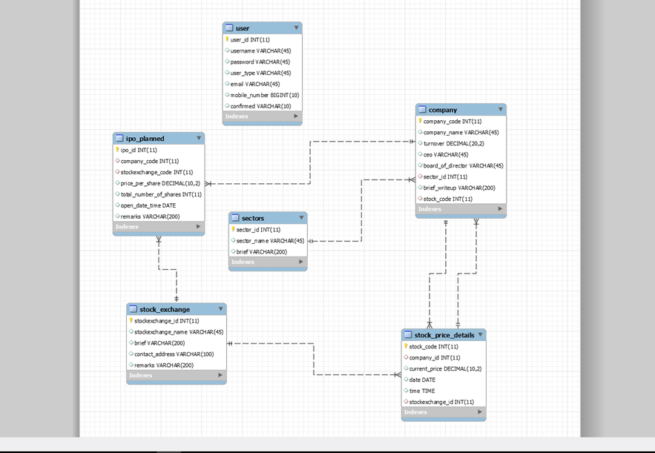

HTML PAGES

SIGN IN /SIGN UP HTML PAGE

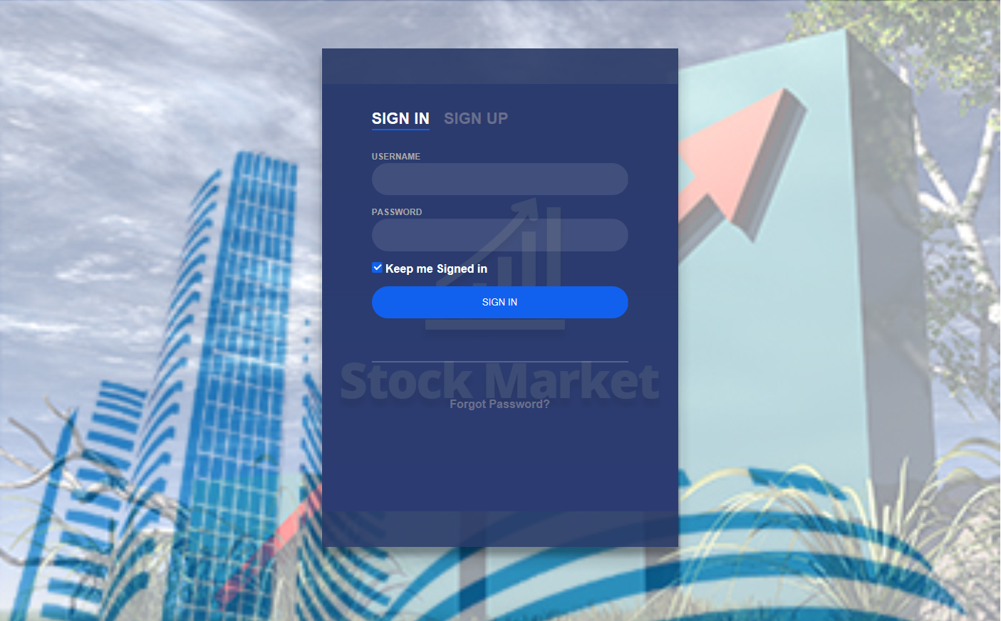

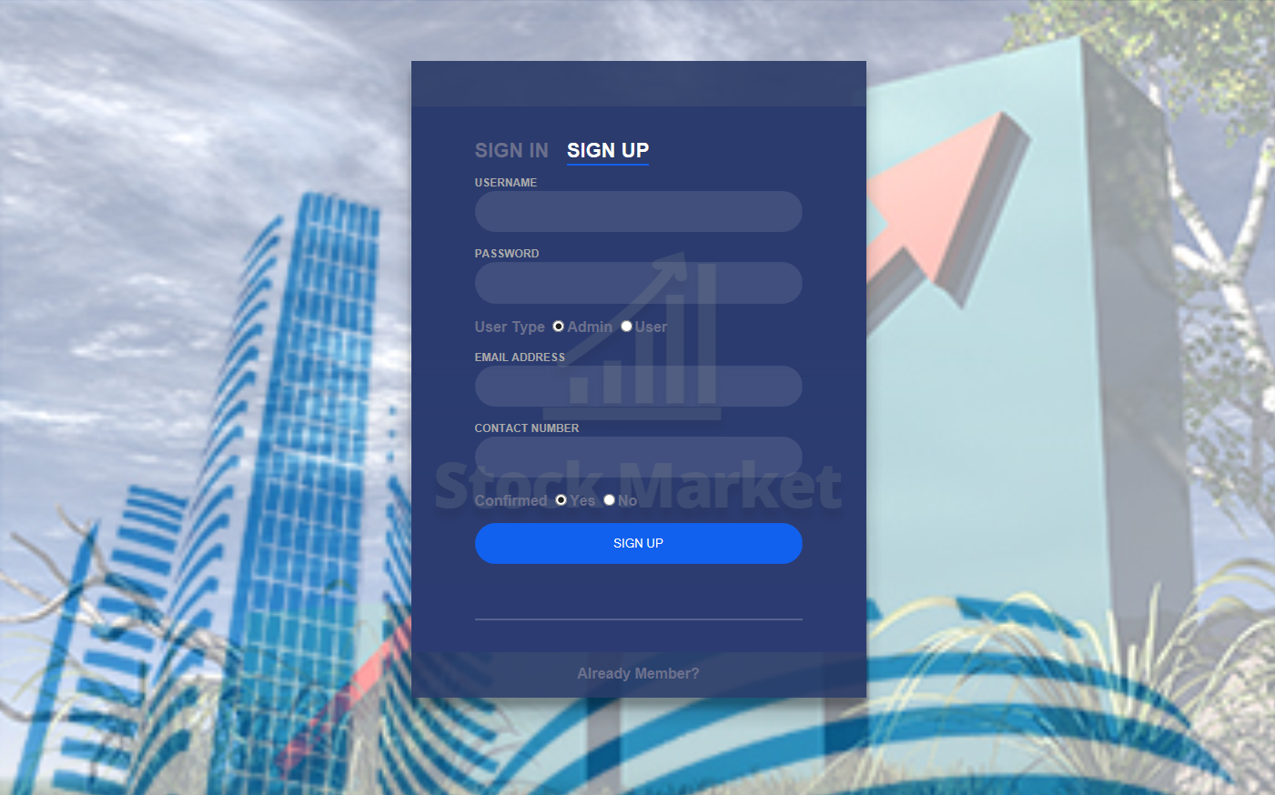

ADMIN HOME PAGE

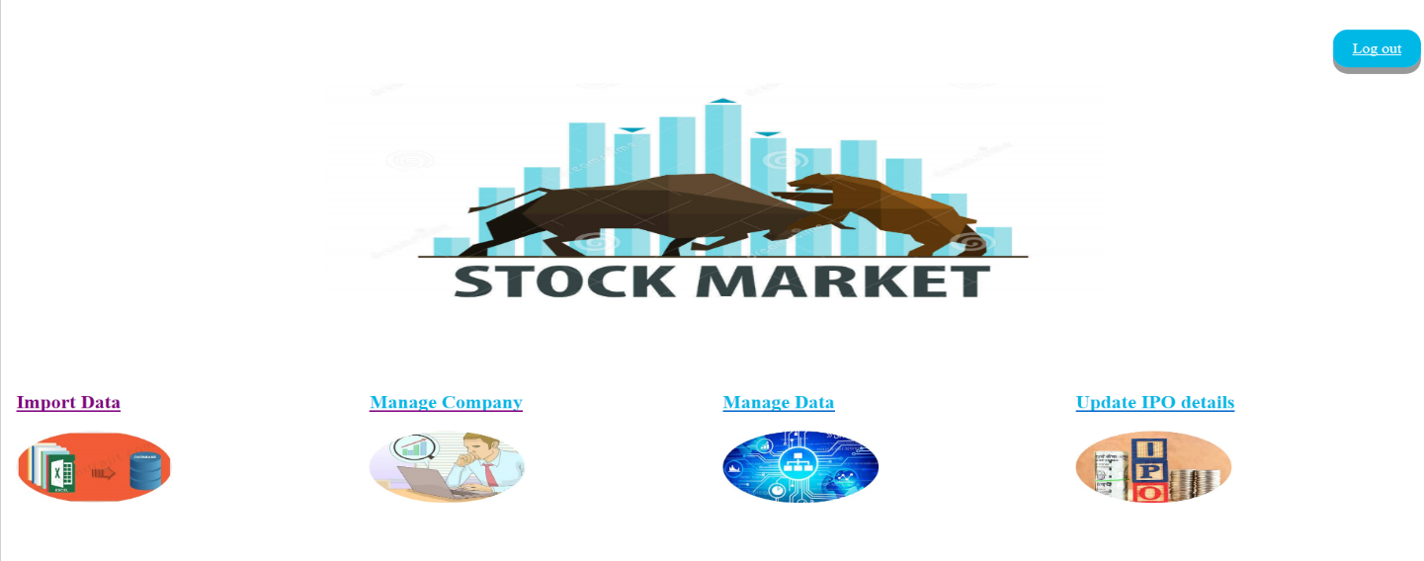

IMPORT DATA PAGE

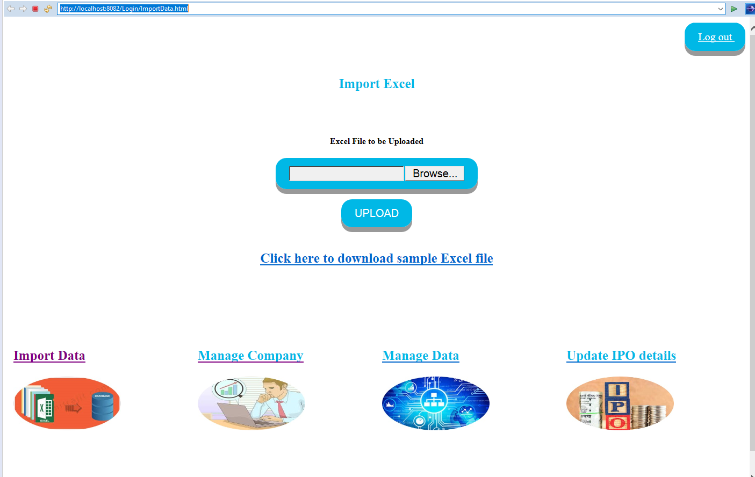

UPLOAD PAGE

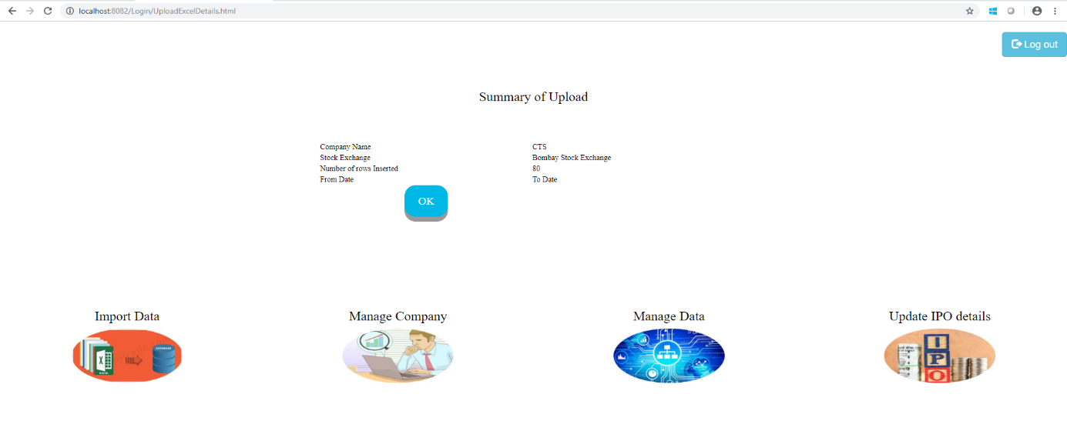

UPLOAD SUCCESS PAGE

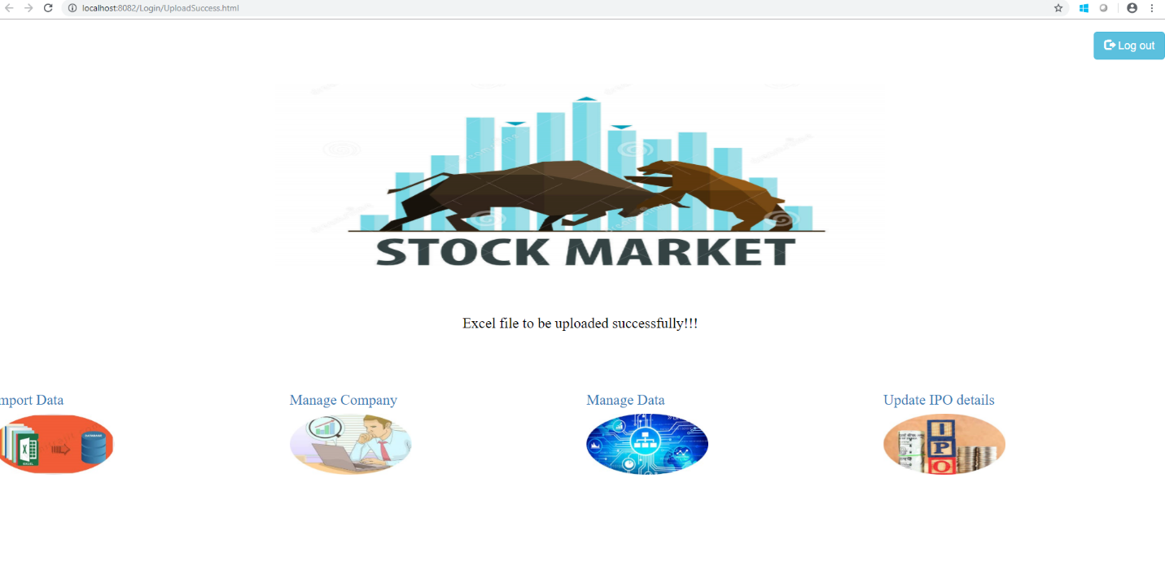

MANAGE COMPANY PAGE

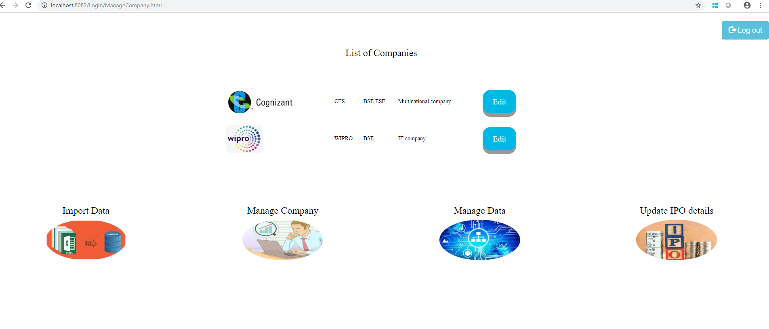

USER HOME PAGE



CREATE NEW COMPANY

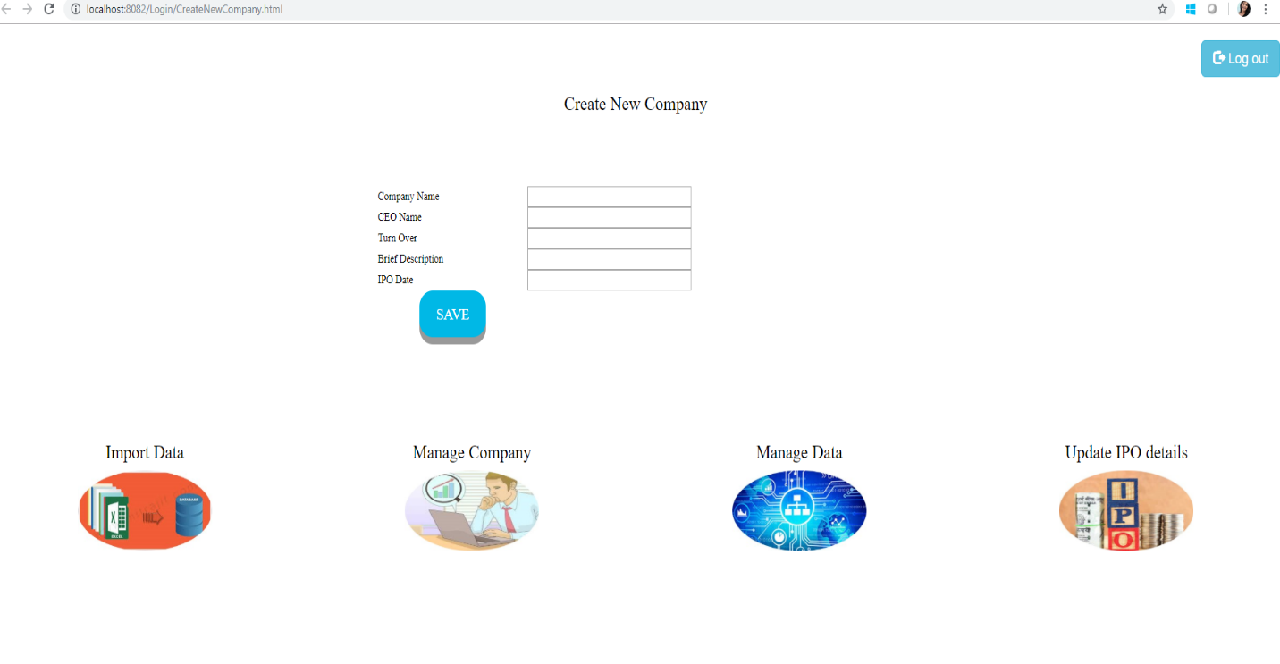GIT HUB LINK :

https://github.com/AayshaBegamAbubakar/stock_exchange.git